Casual Support Worker
Location: Edinburgh, Glasgow, South Lanarkshire, Inverness, Orkney
Rate of pay: £10.50 per hour

Job Purpose
The Casual Worker will provide relief cover to assist in the continuation of high-quality residential support within the cultural and ethical framework of Right There. Our programmes provide 24-hour accommodation support for people currently homeless or at risk of becoming homeless and to people transitioning from temporary to permanent or other suitable long-term accommodation.

Role and Responsibilities
- Develop positive, respectful and compassionate relationships with all support staff, wider staff teams and those we support, focusing on their strengths and aspirations as individuals.
- Have a high standard of professional integrity with colleagues and other professionals.
- Establish clear professional boundaries with staff and those we support.
- Develop positive, respectful and compassionate relationships with those we support, focusing on their strengths and aspirations as individuals.
- Have a high standard of professional integrity with colleagues and other professionals.
- Establish clear professional boundaries with those we support.
- Ensuring person centred planning and unconditional positive regard is undertaken by staff.
- Taking a Psychologically Informed Environment (PIE) approach.
- Ensuring support needs of the people we support are being met.
- Ensuring risk assessments are completed and updated.
- Advocating on behalf of those we support.
- Having detailed knowledge of other relevant services.
- Ensuring a safe environment for the people we support, colleagues and others including a high standard of accommodation is provided.
- Regularly auditing files.
- Assist in the collation of data for Right There Key Performance Indicators (KPI) and any required local authority returns / reports.
- Reporting all required Care Inspectorate notifications
- Representing Right There to other agencies or services including Local Authority, Social Work, Housing Services and other relevant services.
- Actively contribute to your service and the organisations development and improvement.
- Participate fully in team meetings.
- Attend and participate in training and share learning experiences.
- Engage in reflective practice.
- Feedback on the review of organisational polices & procedures and local guidelines.
- Promote Right There services through agreed mediums.
- Strive for continuous personal and professional development.
- Engage with any organisational initiatives or working groups such as NHS Healthy Working Lives, Investors in People, etc.

Right There understands the importance of best practice and expects all staff to adhere to:

- Right There’s policies and procedures.
- Scottish Social Services Council (SSSC) Codes of Practice
- Health and Social Care Standards
- Health & Safety legislation and practices.
- Register with any required government bodies and ensure membership is updated and any attributed costs are paid for

What we expect from you

Our values make us who we are and define our actions and behaviours every day. We’d expect the post-holder to uphold and represent our organisation in a way that reflects our values and person-centred way of working.
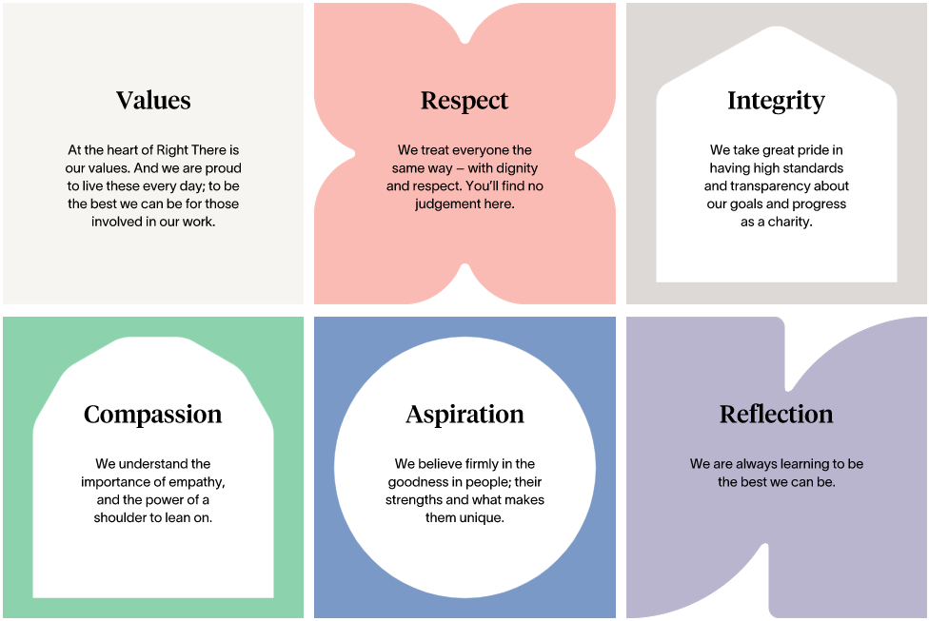

What you can expect from us

We value our staff as our greatest asset and will provide the following working conditions:
.
- The post holder will report to the Senior Support Worker and through them to the Service Manager
- Casual Support Workers work on an infrequent and ad hoc basis.
- Right There is under no obligation to offer you work.
- You are under no obligation to accept work offered by Right There.
- 6 weeks annual leave (pro-rata) per year. The equivalent of one week’s holiday pay is calculated based on the average weekly hours worked over the preceding 12-week period.
- Following a 3-month period you will be automatically enrolled in the People’s Pension scheme if you meet enrolment requirements.
- Due to the nature of our work, you may be asked to work at different locations depending on operational requirements.

Person Specification – Casual Support Worker

Qualifications | Behaviour | Essential Knowledge
Qualifications |  | Qualified to SVQ Level 3 H&SC or SCQF equivalent (or are willing to work towards).
 |  | Desirable Knowledge
First Aid Certificate
Experience of working in a similar environment
Understanding of working within a Psychologically Informed Environment (PIE).
Values and Competency | Behaviour | Essential Skills and Experience
Respect-Interpersonal Skills  Integrity-  Leadership and Accountability  Compassion-  People Focus  Aspiration-  Developing People and Services  Reflection-  Continuous Improvement | Ability to communicate effectively with people at all levels in a variety of situations  Ability to work cooperatively with others as part of a team demonstrating commitment to group objectives  Ability to contribute/assist in building relationships with the people we support  Understanding and respecting the importance of confidentiality  Ability to understand and consider the views, concerns and needs of others when taking action  Ability to assist the Support Workers to implement the aims and objectives of Right There  Commitment to continuous personal and professional development | Ability to contribute towards/assist in meeting performance targets as required  Ability to contribute towards competing demands and priorities as required  Ability to compile reports as required  Computer literate and competent with Microsoft Office software package  Ability and skills to work effectively, manage time and contribute to meeting deadlines as required  Ability to respond/contribute at short notice to crisis situations

